AM,C-Taino- Ceremonial Celt-15 in

Taino Ceremonial Celt Very Large

Tip Broken off and professionally repaired,

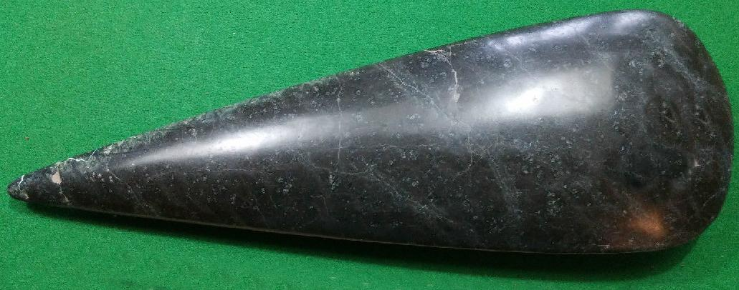

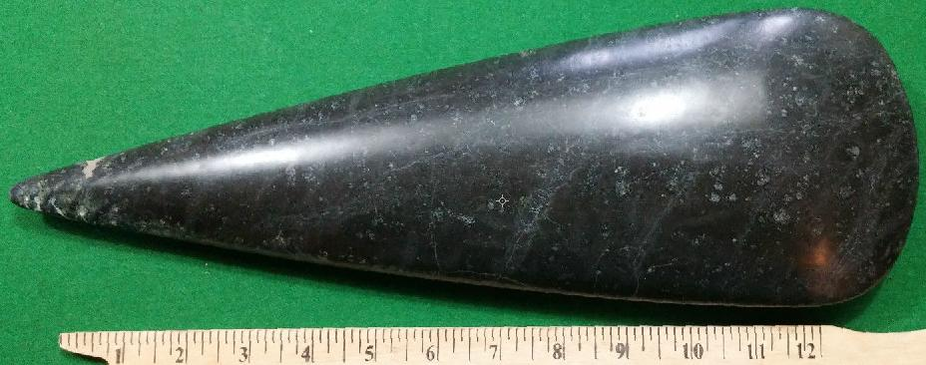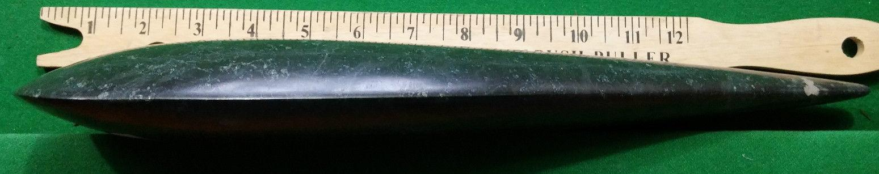

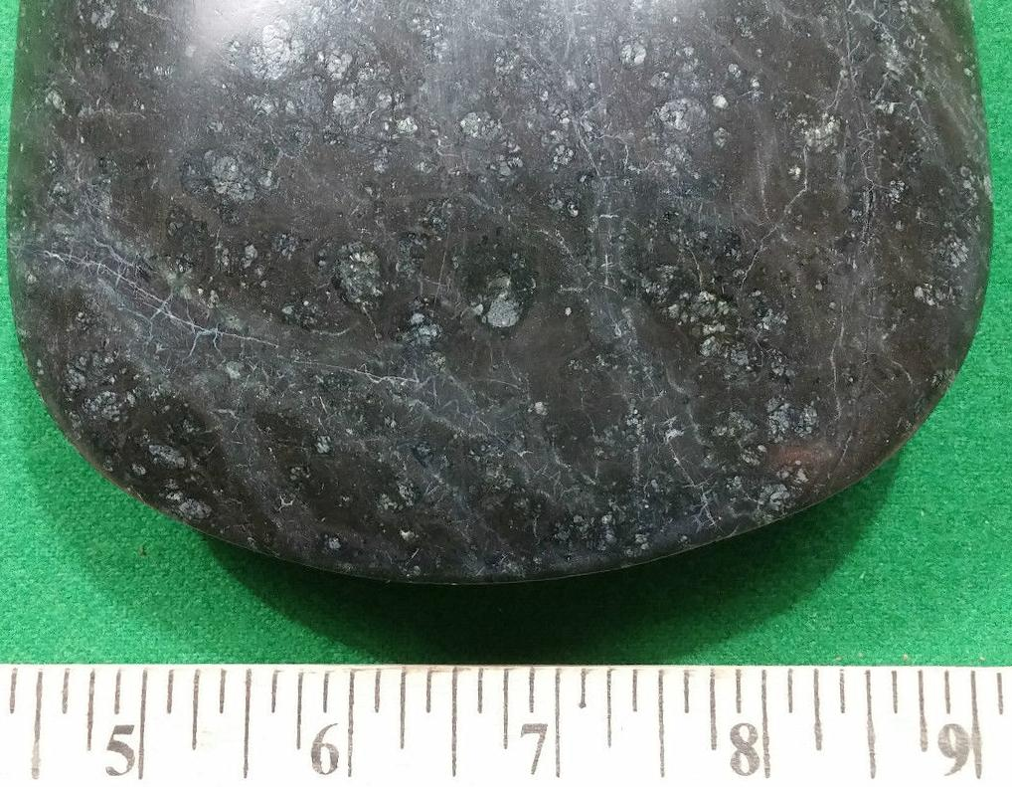

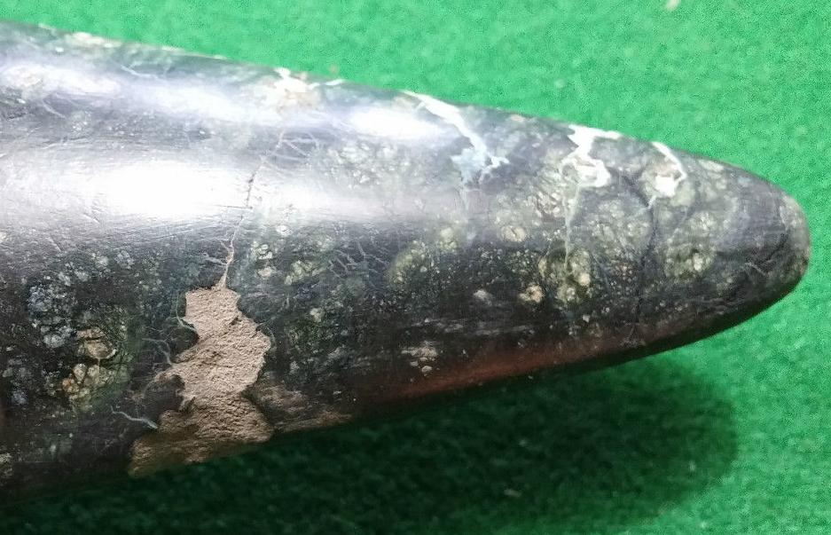

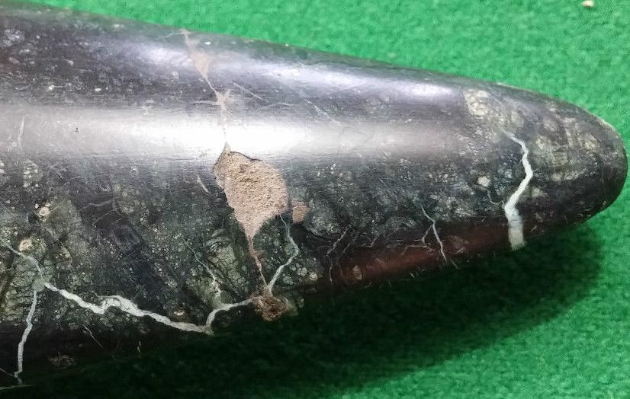

# Order details

## Sales order

Sold by [user1billion](http://myworld.ebay.com/user1billion) ( [777](http://feedback.ebay.com/ws/eBayISAPI.dll?ViewFeedback&userid=user1billion) )

### Delivery package 1 of 1

Estimated delivery Friday, Jan 8, 2016 - Friday, Jan 15, 2016

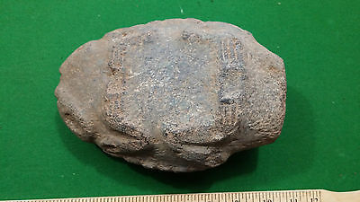

#### [Taino Stone Double sided carving very old - Pre Columbian](http://www.ebay.com/itm/161924648329)

|  |  |
| --- | --- |
| Item price | $339.00 |
| Quantity | 1 |
| Item number | 161924648329 |
| Shipping service | Standard Int'l Shipping |

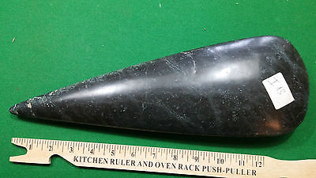

#### [Taino Stone Ceremonial Celt Very Large and Very Rare](http://www.ebay.com/itm/161924654919)

|  |  |
| --- | --- |
| Item price | $177.50 |
| Quantity | 1 |
| Item number | 161924654919 |
| Shipping service | Standard Int'l Shipping |

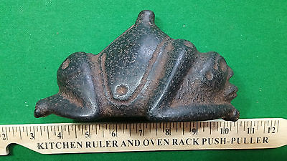

#### [Taino Stone Carving - Pre Columbian](http://www.ebay.com/itm/161924658925)

|  |  |
| --- | --- |
| Item price | $249.00 |
| Quantity | 1 |
| Item number | 161924658925 |
| Shipping service | Standard Int'l Shipping |